Ideation Phase
Empathize & Discover

Date | 11 October 2026
Team ID | SWUID2026399565
Project Name | IMovies – Movie Ticket Booking Made Simple
Maximum Marks | 4 Marks

Empathy Map Canvas:
Understand the needs, frustrations, and behaviours of movie-goers who want to book tickets quickly and without hassle through a platform like IMovies.
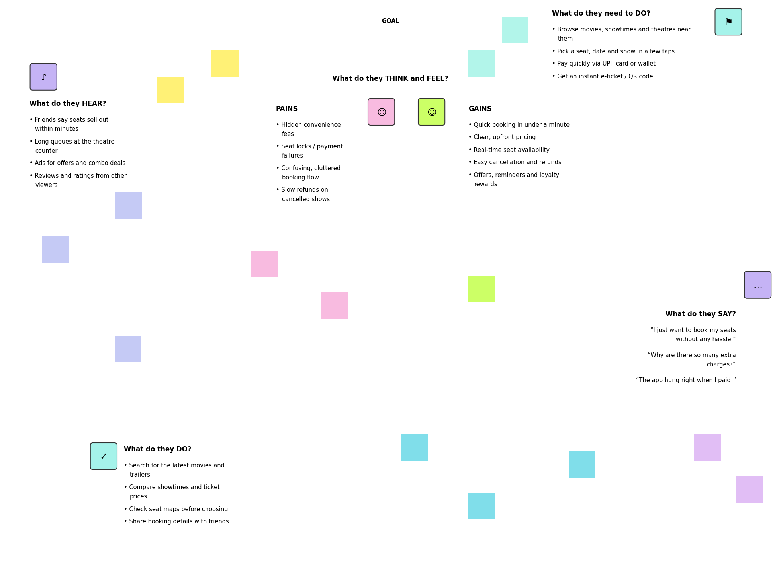
Reference: https://www.mural.co/templates/empathy-map-canvas

